<https://github.com/SonNXP/ftgo-application>

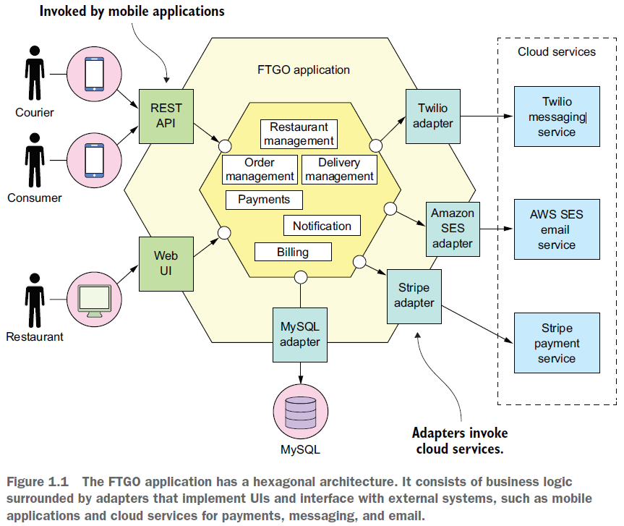

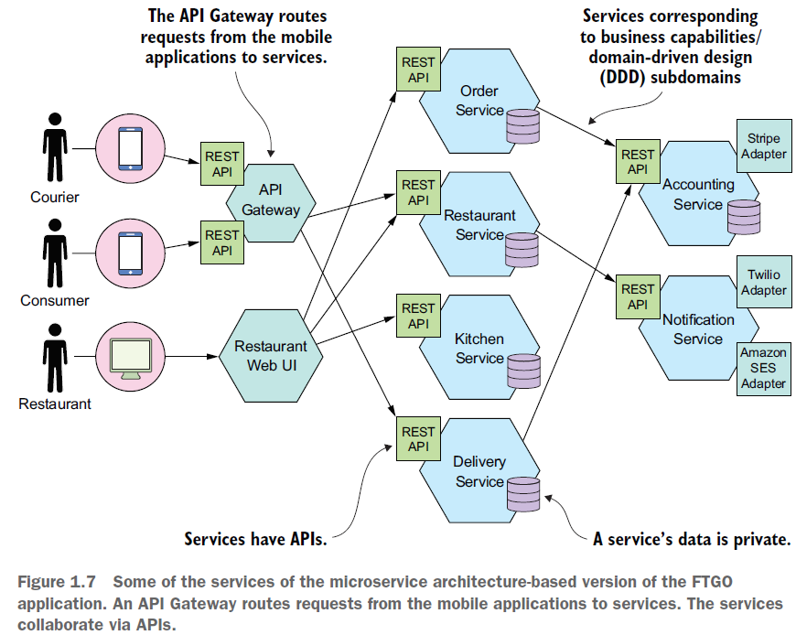

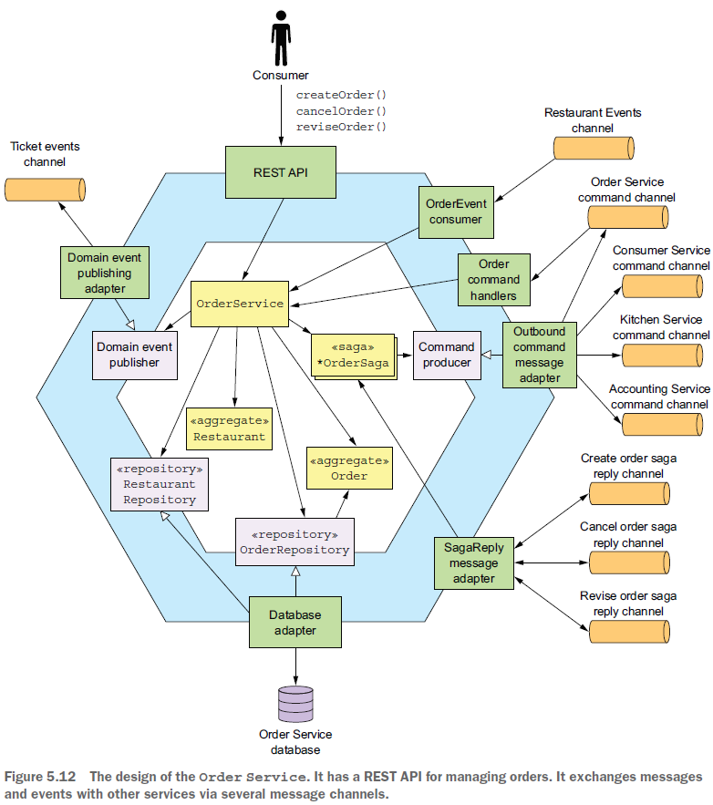

REST API: @Controller or @RestController

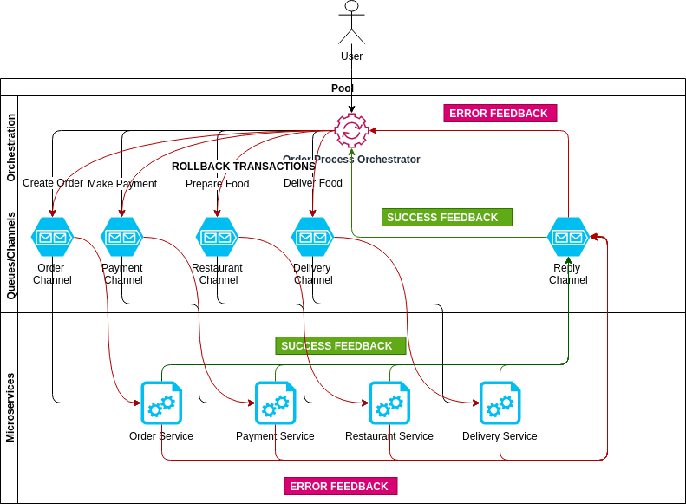

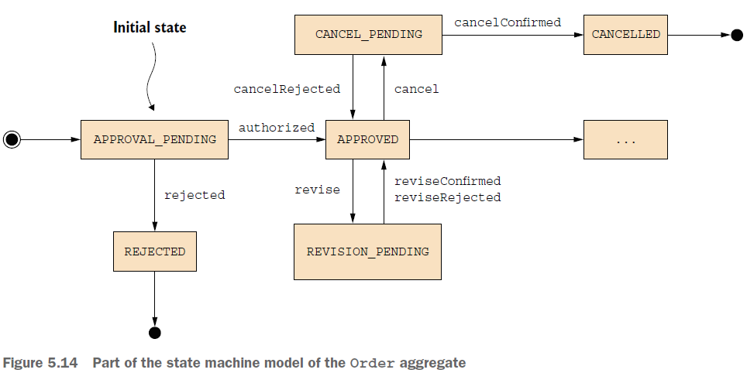

Similarly, other Order Service operations such as revise() and cancel() first change the Order to a pending state and use a saga to verify that the operation can be performed. Then, once the saga has verified that the operation can be performed, it changes the Order transitions to some other state that reflects the successful outcome of the operation. If the verification of the operation fails, the Order reverts to the previous state. For example, the cancel() operation first transitions the Order to the CANCEL_PENDING state. If the order can be cancelled, the Cancel Order Saga changes the state of the Order to the CANCELLED state. Otherwise, if a cancel() operation is rejected because, for example, it’s too late to cancel the order, then the Order transitions back to the APPROVED state.

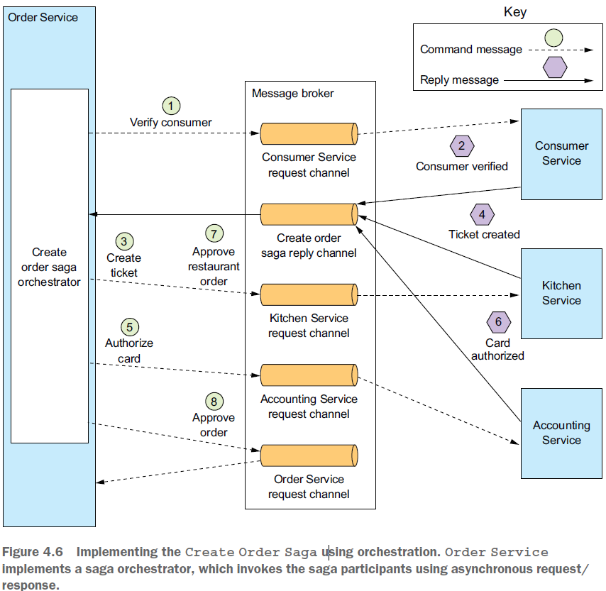

Order Service first creates an Order and a Create Order Saga orchestrator. After that,

the flow for the happy path is as follows:

<https://eventuate.io/docs/manual/eventuate-tram/latest/getting-started-eventuate-tram-sagas.html>

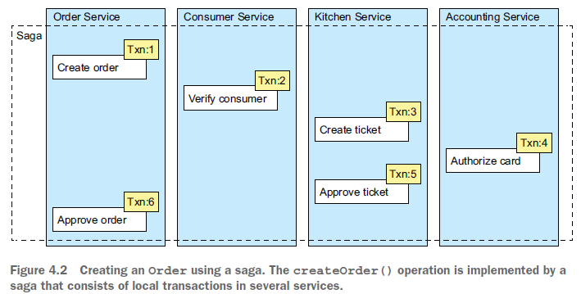

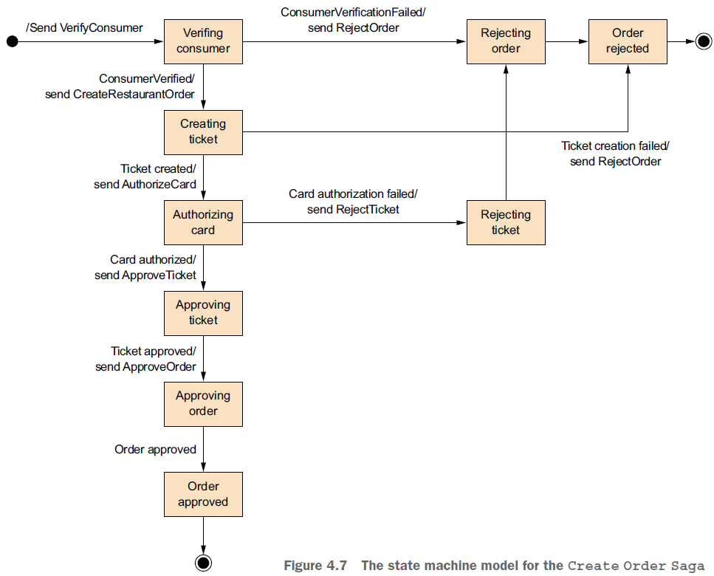

Figure 4.7 shows the state machine model for the Create Order Saga. This state

machine consists of numerous states, including the following:

○ Verifying Consumer—The initial state. When in this state, the saga is waiting

for the Consumer Service to verify that the consumer can place the order.

○ Creating Ticket—The saga is waiting for a reply to the Create Ticket command.

○ Authorizing Card—Waiting for Accounting Service to authorize the consumer’s

credit card.

○ Order Approved—A final state indicating that the saga completed successfully.

○ Order Rejected—A final state indicating that the Order was rejected by one of

the participants.

### [Giao dịch có kỳ hạn (Forward Transaction)](http://quantri.vn/dict/details/14094-giao-dich-co-ky-han-forward-transaction)

<https://en.wikipedia.org/wiki/Compensating_transaction>

<https://docs.microsoft.com/en-us/azure/architecture/patterns/compensating-transaction>

Use this pattern only for operations that must be undone if they fail. If possible, design solutions to avoid the complexity of requiring compensating transactions.

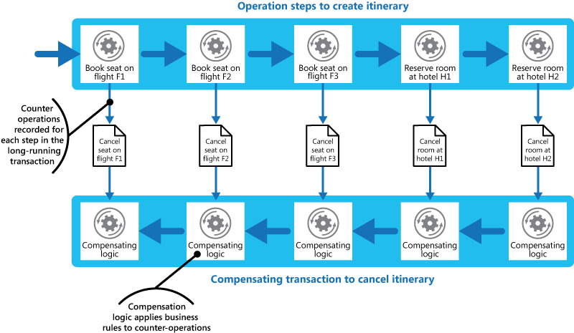

<https://www.prakharsrivastav.com/posts/saga-orchestration-in-microservices/>

# Understanding Orchestration[⌗](https://www.prakharsrivastav.com/posts/saga-orchestration-in-microservices/#understanding-orchestration)

Let’s continue with our previous example of a food delivery system. To implement the SAGA design pattern, we need a central orchestrator called Order Orchestrator. The orchestrator can be a process manager that receives the initial order request. Its core responsibilities are.

* Receive process initiation request and call the first service.
* Listen to success or failure feedback from the currently running service.
* For successful feedback, ask the next service to proceed.
* For failure feedback, relay a message to all participation services to rollback their transactions.

Revise:

The revise() method is called to initiate the revision of an order. Among other

* things, it verifies that the revised order won’t violate the order minimum (check internal logic of this service first) and changes
* the state of the order to REVISION_PENDING. Once Revise Order Saga has successfully
* updated Kitchen Service and Accounting Service, it then calls confirmRevision()
* to complete the revision.

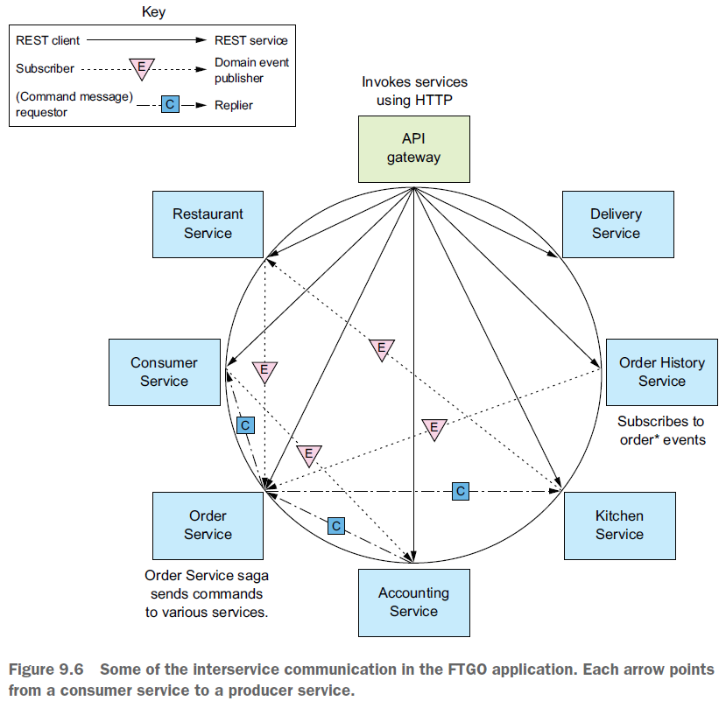

There are two types of unit tests (https://martinfowler.com/bliki/UnitTest.html):

○ *Solitary (đơn độc) unit test*—Tests a class in isolation using mock objects for the class’s dependencies

○ *Sociable (hòa đồng) unit test*—Tests a class and its dependencies. Detail in OrderTest.java. These kind of unit test does NOT use mocks, stubs. It makes real needed (dependencies) objects with real values for testing and use AssertEquals to check.

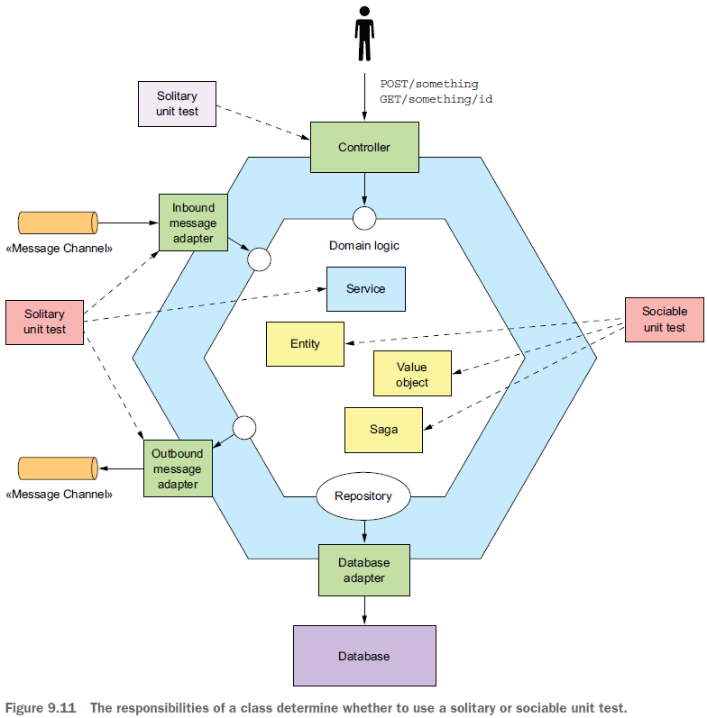

○ *Solitary (đơn độc) unit test*—Tests a class in isolation using mock objects for the

class’s dependencies

○ *Sociable (hòa đồng) unit test*—Tests a class and its dependencies. These kind of

unit test does NOT use mocks, stubs. It makes real needed (dependencies) objects

with real values for testing and use AssertEquals to check.

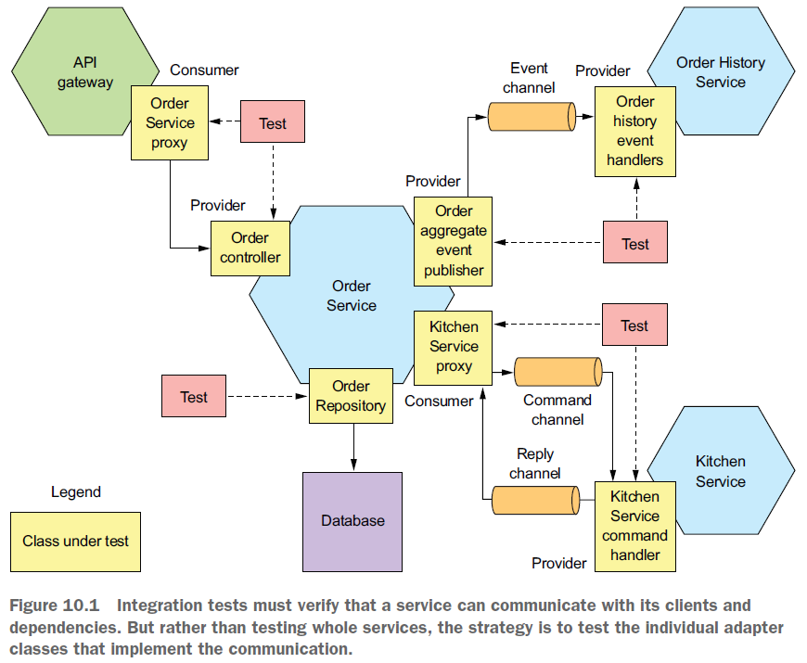

aws cloud. amozon cloud. config thu tao virtual server tren cloud. AWSBat server. Cai phan mem, microserver.

2 types:

Scrum: planning

Kanban:

AWS EC2: Amazon Elastic Compute Cloud (Amazon EC2) is a web service that provides resizable computing capacity—literally, servers in Amazon's data centers—that you use to build and host your software systems.

NoSQL (MongoDB)

